
LSR445SD-OEM
1000~2000mW Blue Laser
FEATURES
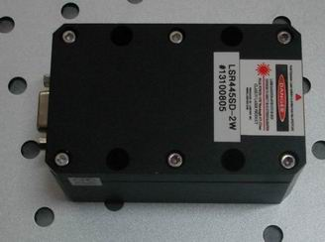
Small Divergence
TEC cooled
Longlife operation

Analog/TTL modulation
Collimated straight beam
High efficiency
High reliability

APPLICATIONS
Laser show
Display
Laser Alignment
Scanning Biochemistry
Material Inspection Lidar

Specifications
Model No. | LSR445SD
Wavelength | 445+/-5 nm
Spatial Mode | Near TEM00
Output Power | 1000mW，1500mW， 2000mW
Operation Mode | CW or Modulation
Beam Height | 29mm
Beam Size | 4.5x4mm
Beam Divergence(full angle) | 1.2x0.5mrad
Power Stability | <3% per 4 hrs
Temperature Stabilizing | TEC
Warm Up Time | <1 minute
MTTF | 10,000 hr
Laser head dimensions | 89.5(L)x56(W)x45(H)mm
Power Supply | A. OEM type  LSR-PS-I: 100(L)x58(W)x32(H)mm3  AC/DC PSU: 85~265V 50/60Hz input
Power Supply | B. Lab type  LSR-PS-IIS: 104(W)x128(D)x89(H)mm3  85~265V 50/60Hz input
Power Supply | C. Lab Adjustable type  LSR-PS-IIS: 179(W)x148(D)x56(H)mm3  85~265V 50/60Hz input
Modulation | 0~30khz Analog or TTL

Laser head
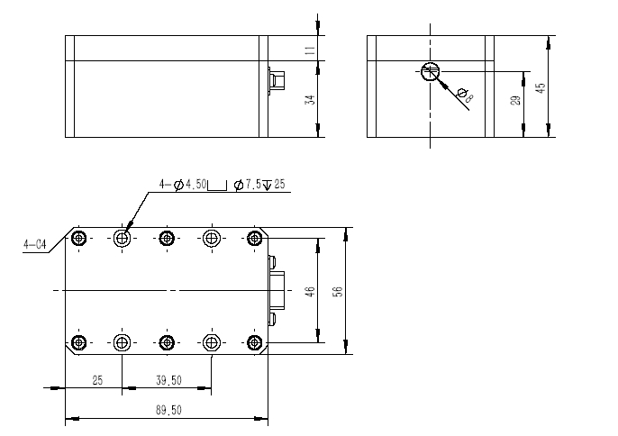

A. OEM type power supply
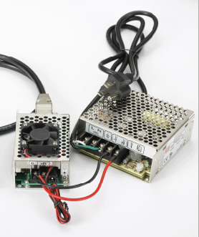
B. Lab type
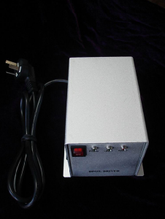

C, Adjustable type
